**Detail Step**

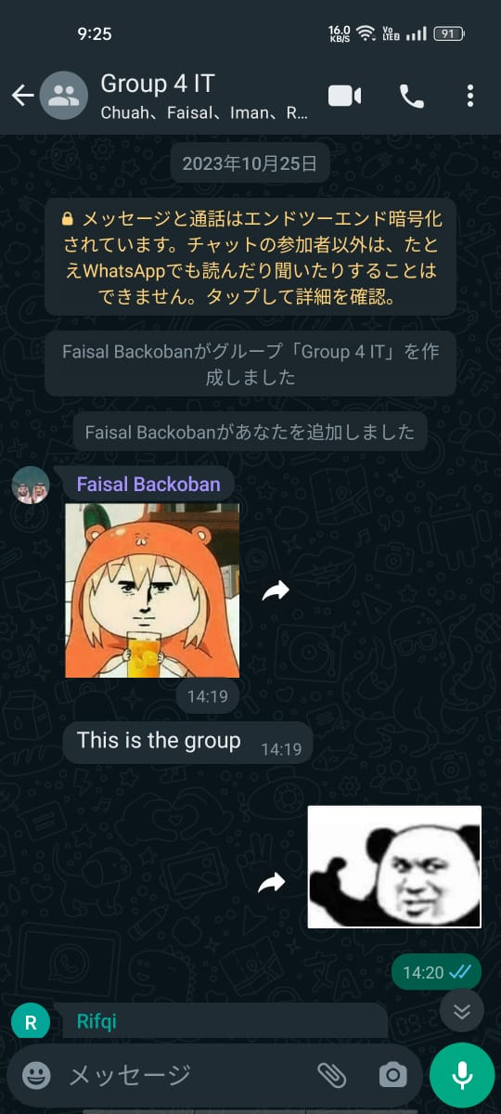 We were given a group project about design thinking on 25/10/23 and we created a whatsapp group for discussion about the project. After that, our group members had given a few ideas for the topic of our project. Eventually, we finalised our topic for the project on 08/11/23 after group discussions. Next, we divided tasks to every member and start our work for the project. Through survey from UTM students using Google form and phone interview with first year student, we found that UTM students are having issues with reaching out seniors and lecturers to ask opinions for their problems related to academic activities or campus life. We decided to come up with a solution for these problems in this project.

*(image 1: Created whatsapp group)*

Log Journal:

|  |  |
| --- | --- |
| Date | Activity |
| 25/10/23 | * Create whatsapp group for discussion about the project. |
| 28/10/23 | * First meeting to discuss about the project. * Groups members brainstorming for the topic of our project. |
| 03/11/23 | * Meeting to discuss about the project. * Giving new ideas for the topic of our project. |
| 08/11/23 | * Finalised the topic of our project. |
| 09/11/23 | * Divided tasks to every group member. |
| 10/11/23 | * Conducted survey from UTM students using Google form. |
| 11/11/23 | * Phone interview with first year student. |
| 12/11/23 | * Discussion about the problems and finding solutions. * Decided our solution. * Start making prototype. |
| 15/11/23 | * Making initial report. * Submit initial report. |
| 17/11/23 | * Making video. |
| 28/11/23 | * Finish video. |
| 29/11/23 | * Finalise report, ready to submit. |
| 30/11/23 | * Submit the report and video |

**Detailed Description (Problems, Solution, Team working)**

Problems:

In empathize phase, we started gathering the problems met by UTM students through Google form survey and interviews. From data collected from the Google form survey and interviews, we found that majority of the students are rather not to bother lecturers when they encounter questions related to their academic activities such as assignments or projects. There are also some students claiming that they are shy to ask questions during lectures. After group discussions, we defined that these problems are caused by the lack of a proper platform for students to seek answers for their questions.

Solutions:

We started to discuss about the solutions for the problems and brainstorm for the solutions. Through some discussions, we settled on a solution which is create a Forum style Application exclusive to UTM students where students can post questions to be solved by seniors. To increase the motivation for the seniors to solve questions for juniors, we decided to implement bounty system which users can choose to reward their answerer.

Team working:

In the process doing this project, we had some inflicts due to different opinions but eventually all of us come to an agreement after communication. After that, we divided our tasks and each of us proceed it smoothly. When encountering problems during the tasks such as project writing and prototyping, we solved them through group discussions steadily. In the end, we are able to finish the project in time with our team working.